Welcome Back Bulldogs! The student academic portal has gotten a new look and a new name! You will be using the Bulldog Dashboard for all of your academic needs, including registering for classes.  Log in at [https://adrian.mycampus-app.com](https://adrian.mycampus-app.com/)

This is your home screen. From the home screen you will be able to view your transcripts, schedule, register for classes, and attendance. To begin registering, click on the “Class Enrollment” link.

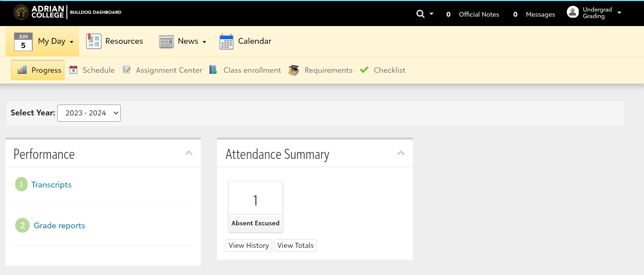

This page will show after you have clicked the “Class Enrollment” link.

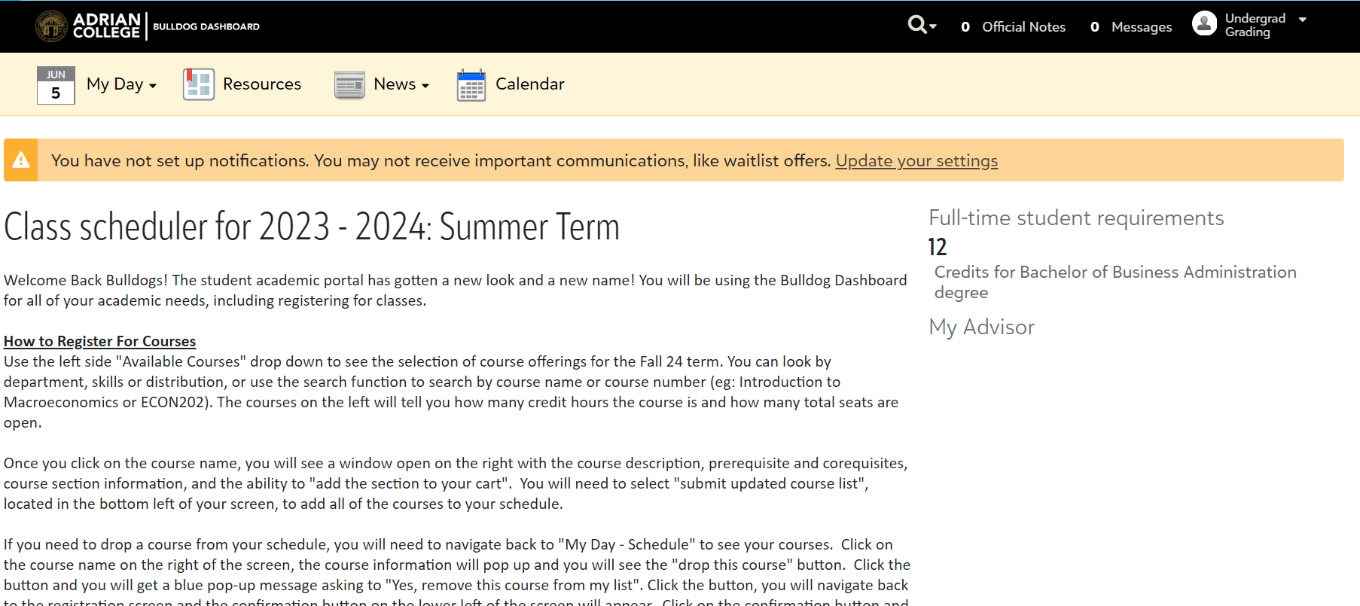  
  
**How to Register For Courses**  
Use the left side "Available Courses" drop down to see the selection of course offerings for the Fall 24 term. You can look by department, skills or distribution, or use the search function to search by course name or course number (eg: Introduction to Macroeconomics or ECON202). The courses on the left will tell you how many credit hours the course is and how many total seats are open.

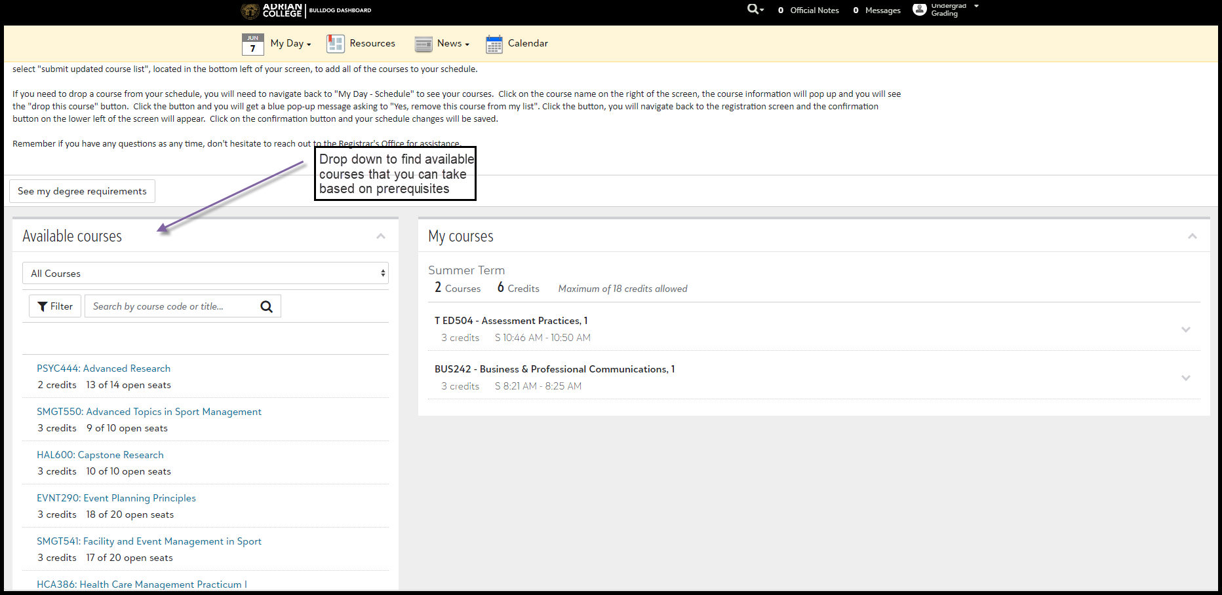  
  
Once you click on the course name, you will see a window open on the right with the course description, prerequisite and corequisites, course section information, and the ability to "add the section to your cart".

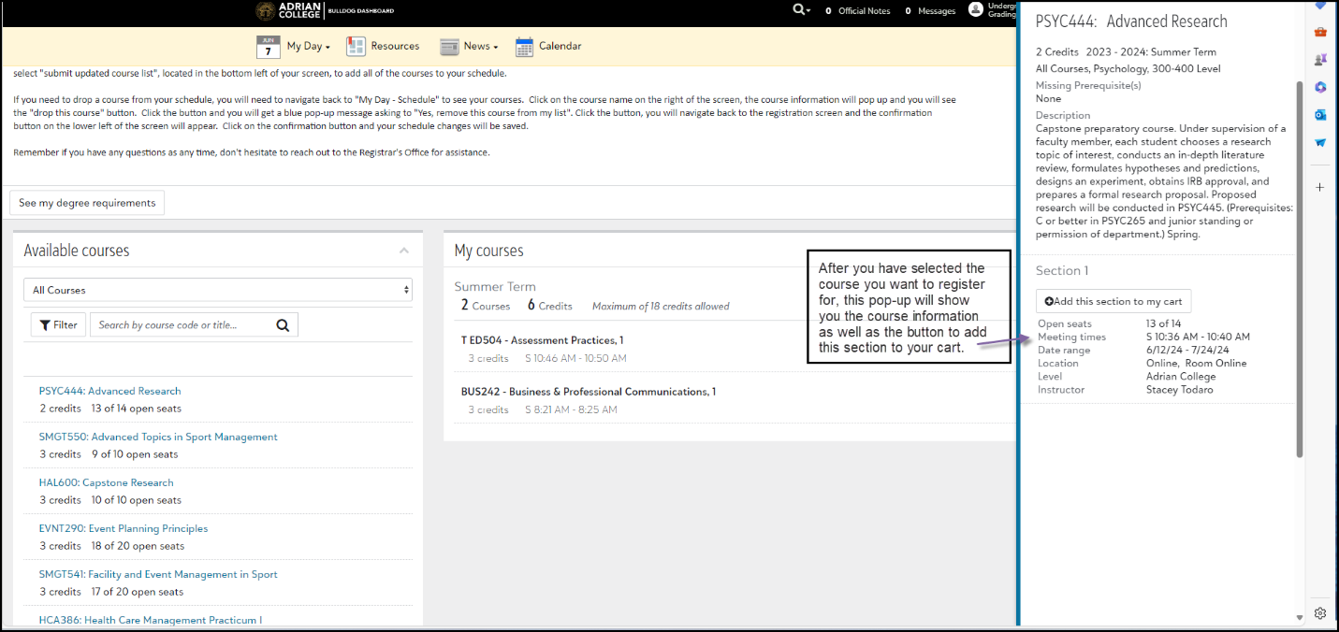

You will need to select "submit updated course list", located in the bottom left of your screen, to add all of the courses to your schedule.

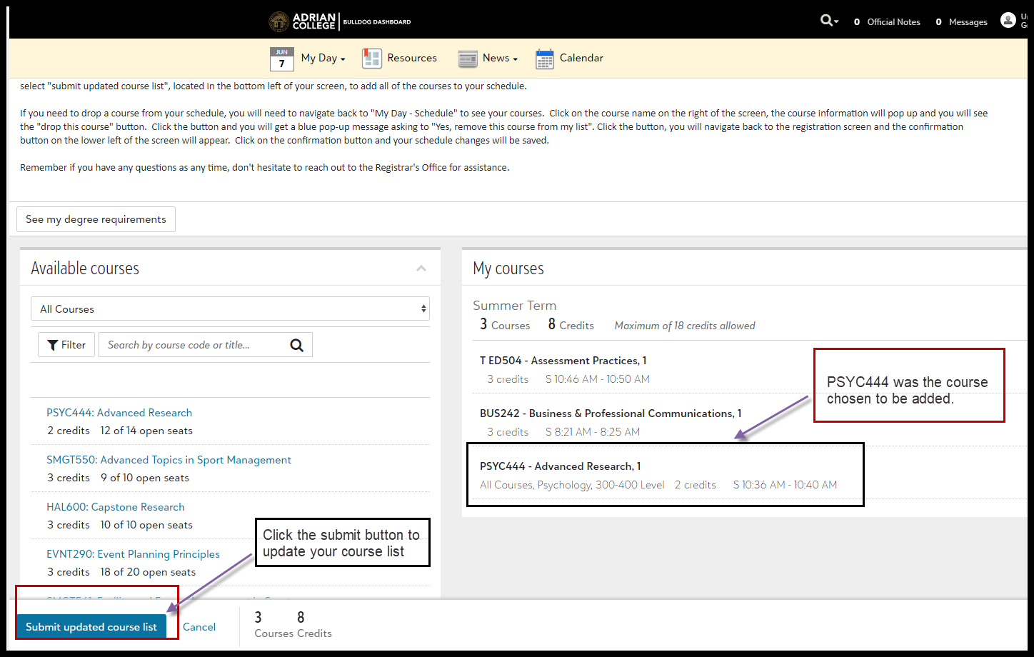

Click “Yes, finish enrolling” and you are all finished adding a course or courses to your schedule.

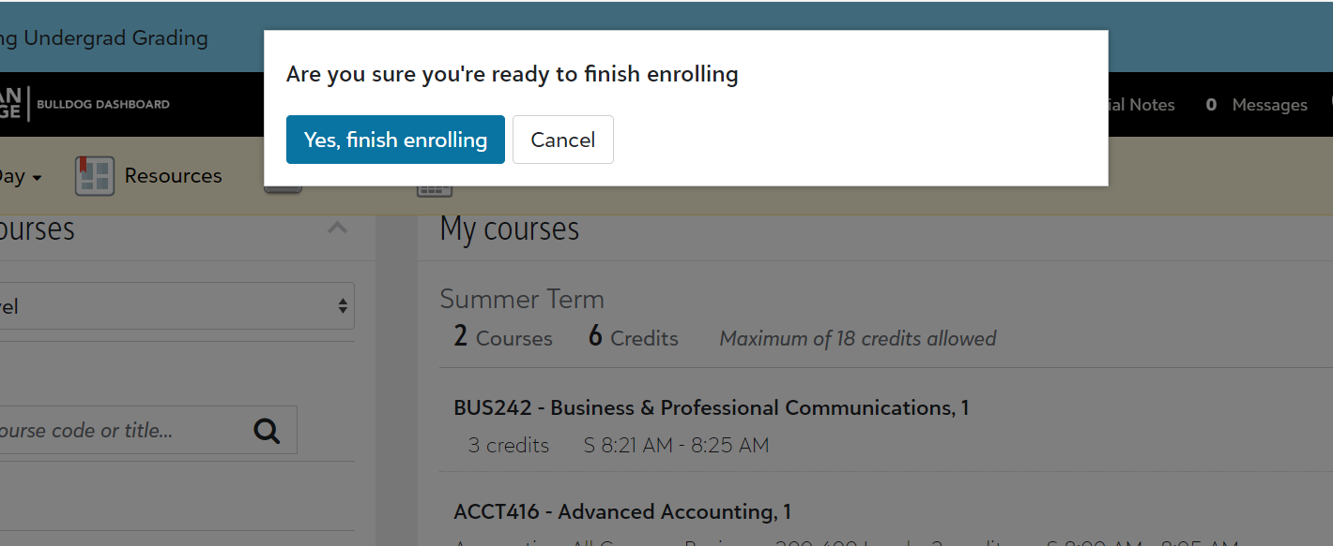

**If you need to drop a course from your schedule,** you will need to navigate back to "My Day – Class Enrollment" to see your courses.  Click on the course name on the right of the screen, the course information will pop up and you will see the "drop this course" button.  Click the button and you will get a blue pop-up message asking to "Yes, remove this course from my list".

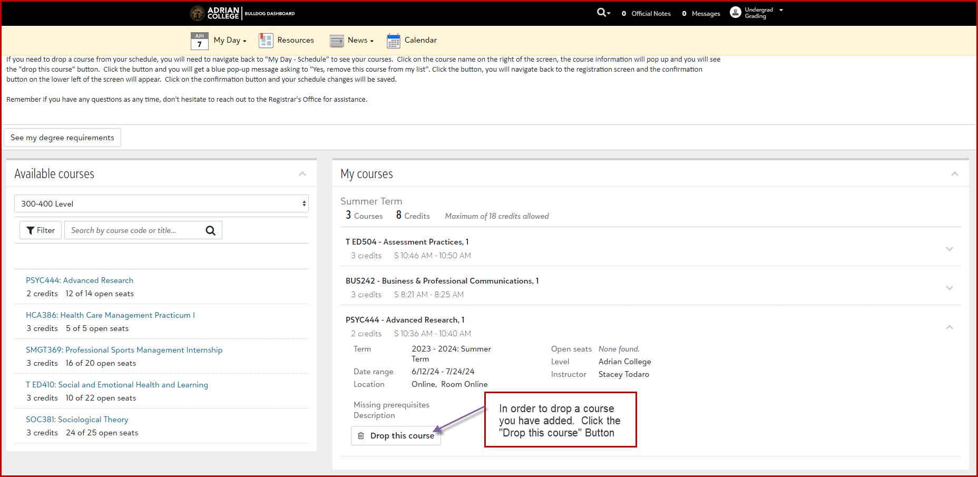

Select “Yes, remove this class from my list” button.  
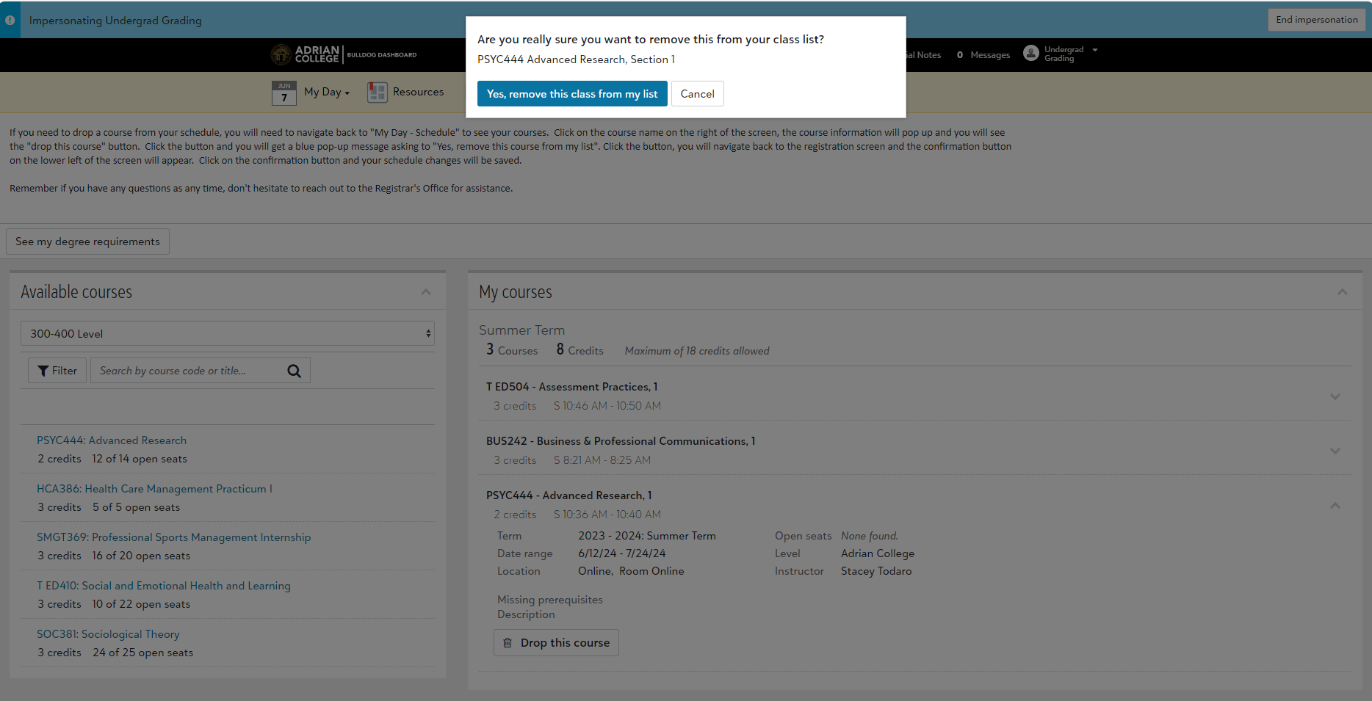

Click the button, you will navigate back to the registration screen and the confirmation button on the lower left of the screen will appear.

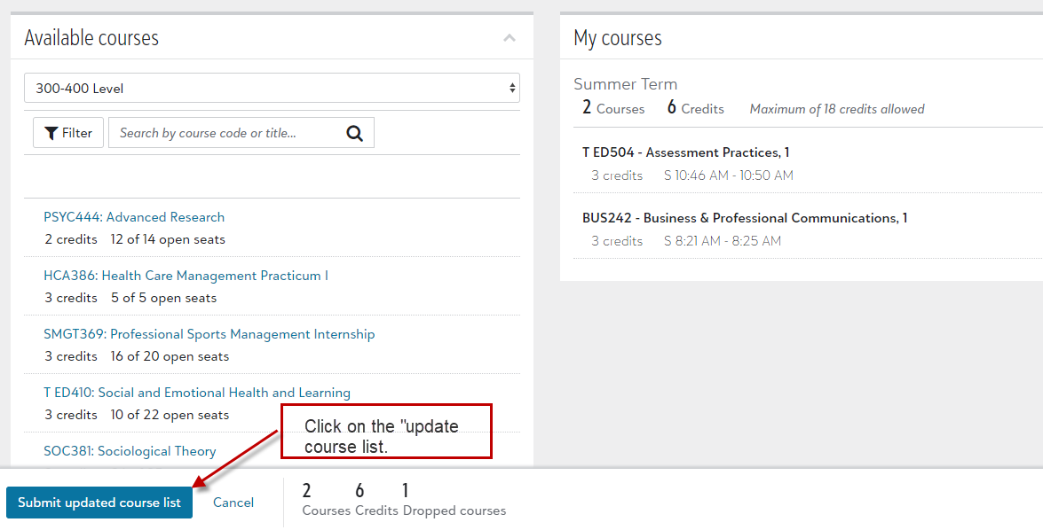

Click on the confirmation button, “Yes, finish enrolling” and your schedule changes will be saved.



After you select “Yes finish enrolling”, you will be directed back to your home page that shows your courses.

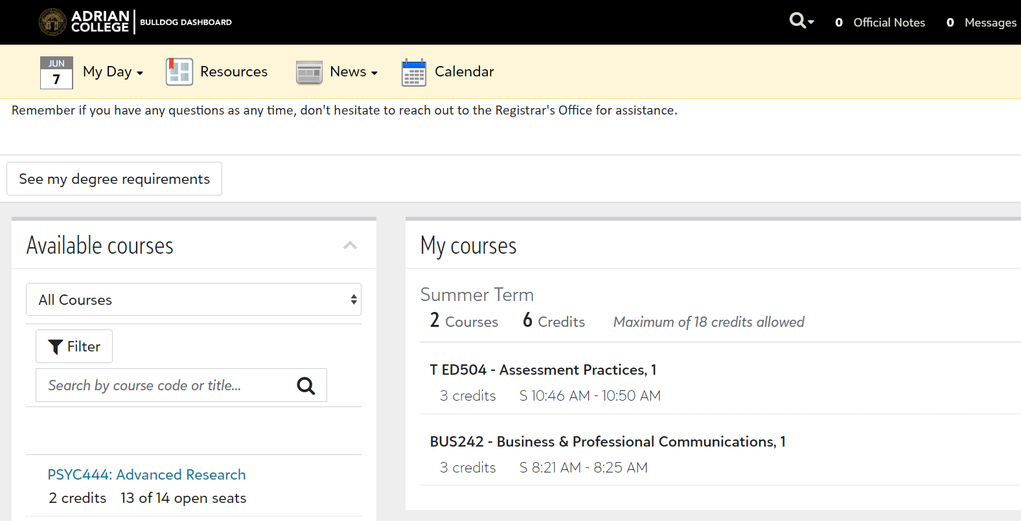

**2024-2025 Important Registration Dates**  
August 27: Last Day to Add/Drop a Term A Course  
September 3: Last Day to Add/Drop a 15-Week Course  
October 24: Last Day to Add/Drop a Term B Course  
October 25: Last day to Withdraw from a 15-week Course  
October 27 - November 8: Advising & Registration for Spring 2025  
October 28: Last Day to Withdraw from a Term B Course  
  
Remember if you have any questions as any time, don't hesitate to reach out to the Registrar's Office for assistance.